
Same or Different Report

M9

Group members
Wanming Yi | 2023304185
Xuanming Che | 2023304252
Mo Zhou | 2023304183
Yibo Wang | 2023304184
Xinye Wang | 2023304199
Ximing Wu | 2023304247

Ⅰ Introduction
This report analyzes zeta potential data of unmodified and Peptide A-modified polystyrene particles to evaluate the effectiveness of surface charge enhancement for targeted drug delivery. It reviews raw data for accuracy, calculates key statistical parameters, and uses graphical methods to assess data distribution and normality. The analysis determines statistical significance of differences between samples using both graphical and numerical methods.

Ⅱ Data Inspection and Evaluation
2.1 Discussion of Raw Data and Handling of Data Issues
Adhering to zeta potential quality criteria (SD ≈10% of mean, minimum 2 mV), the SD/Mean ratio was calculated and plotted in comparative line charts (Figure 2-1). This method highlights deviations from the expected range, enabling outlier identification. Visual analysis identified four data with significant anomalies.
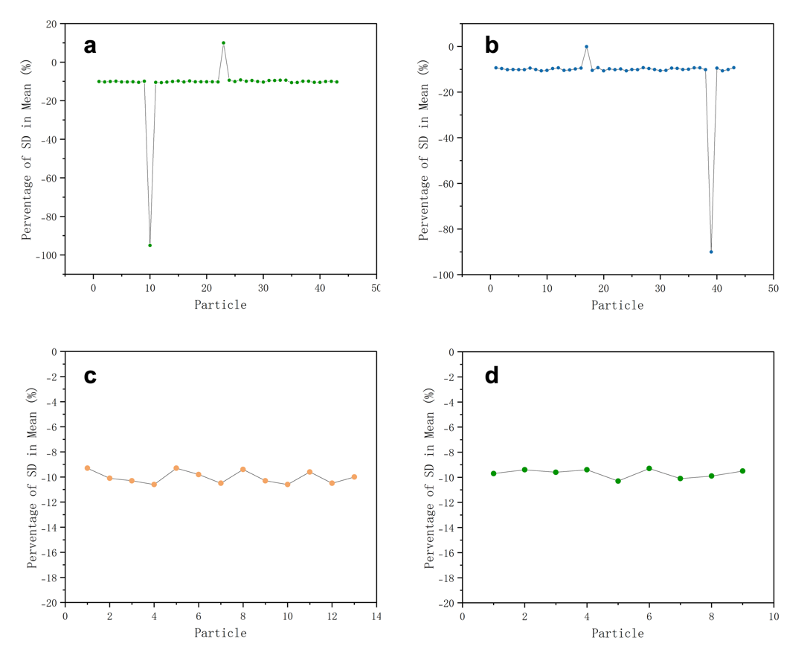
Figure 2-1. SD proportion distribution of particles. (a)PS-X. (b)PS-Y. (c)PA-C. (d)PA-N
As shown in Table 2-1, data points 1 and 4 likely had missing digits during recording, leading to inconsistent magnitudes. With only three significant figures and no way to restore them, these points should be discarded. Data point 2 has an SD value with a similar magnitude but an opposite sign compared to valid values; it is corrected to -67.74 mV by adding a negative sign. Data point 3, with four significant figures, appears to have a missing decimal point, so the original -8006 mV is corrected to -80.06 mV.

Table 2-1. Mistake types
No. | Data Point | Data | Decision
1 | Student X (10) | -6.66 mV | Exclude this data point
2 | Student X (23) | 67.74 mV | Retain this data point with correction
3 | Student Y (17) | -8006 mV | Retain this data point with correction
4 | Student Y (39) | -7.87 mV | Exclude this data point

2.2 The quality of the results in the zeta-potential
To judge whether the results are reliable, two things need to be considered. On the one hand, is the quality of the 30-cycle test process, and on the other hand is the overall quality of the test results.

For the testing process, a good rule to evaluate the quality of the zeta potential is an SD of about 10% but not less than 2mV, and data closer to 10% is of higher quality. For PS-X and PS-Y data, the SD values are between -9%-11%, which can be considered that each zeta potential has a good quality.
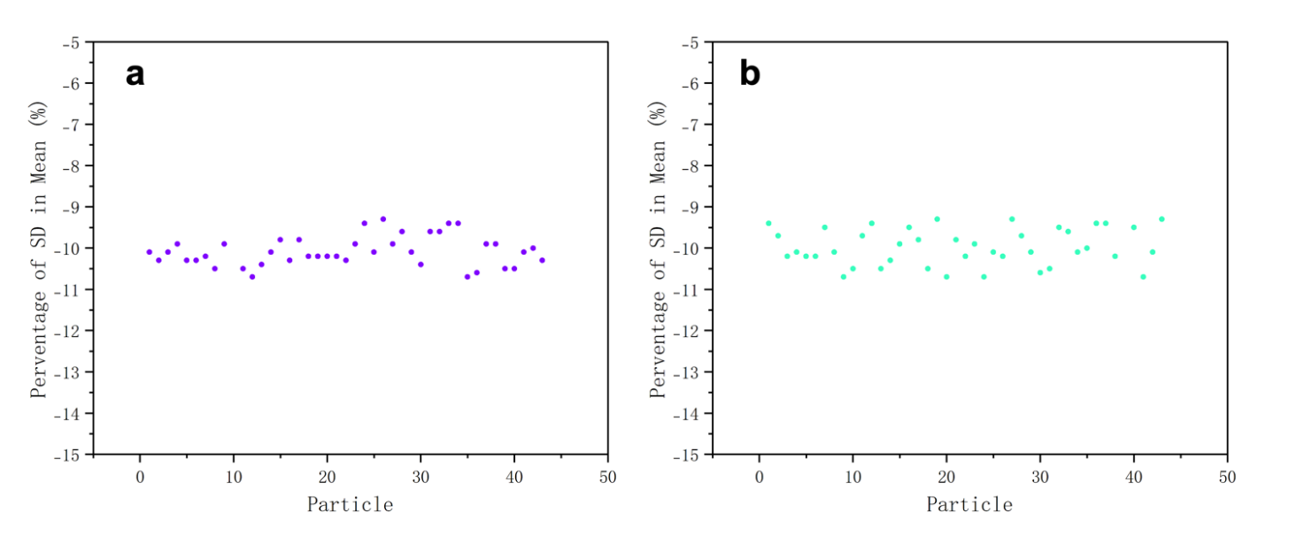
Figure 2-2. The SD proportion distribution of modified particles. (a)PS-X. (b) PS-Y
For the test results, the quality assessment metric is defined as the absolute deviation between individual data points and the overall mean value, where smaller deviations indicate superior data quality. Box plots can be drawn using the interquartile range (IQR) method to identify outliers beyond 1.5 times the IQR. For PS-X, four data points are outliers: -53.98 mV, -87.82 mV, -86.87 mV, and -84.93 mV. For PS-Y, two data points are outliers: -93.78 mV and -95.48 mV. Values closer to the mean value indicate higher quality.
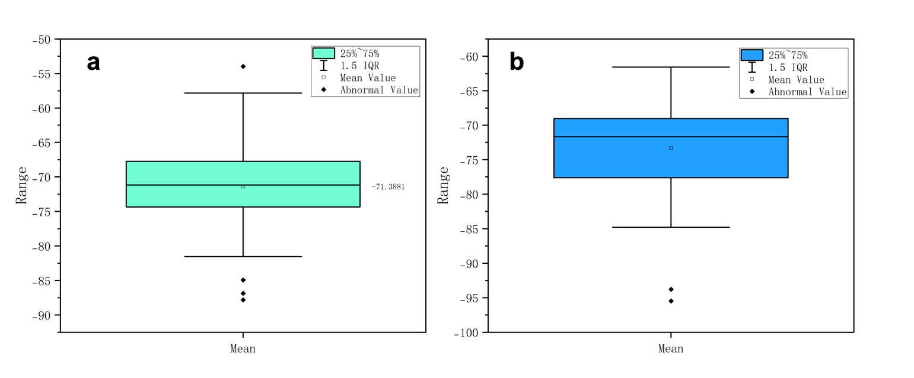
Figure 2-3. Box plots of test results for (a) PS-X and (b) PS-Y

Ⅲ Analysis of Data
3.1 Calculation of Data Eigenvalues

Table 3-1. Calculation of Data Eigenvalues
Eigenvalue | Formula
Mean | $$\overline{X}=\frac{\sum{X}}{n}$$
Mode | Most commonly occurring value in a set of numbers
Median | $$\left\{\begin{aligned}x_{\frac{n+1}{2}， n is odd} \\ \frac{x_{\frac{n}{2}}+x_{\frac{n}{2}+1}}{2},n is even\end{aligned}\right.$$
SD | $$SD=\sqrt{\frac{\sum{{(x-\overline{x})}^{2}}}{n-1}}$$
SE | $$SE=\frac{SD}{\sqrt{n}}$$
CI | 95% confidence interval =±1.96 SD of mean
CoV | $$CoV=\frac{SD}{Mean}×100$$

Through calculating the result from the above formula and rounding, the valid zeta potentials with significant figures can be obtained.

Table3-2. Reporting dataset with characterizing variation
 | Mean (mV) | Median (mV) | Mode (mV) | SD (mV) | CI (mV) | CV | SE (mV)
Unmodified particles - X | -71 | -71 | -71 | 7.22 | 2.18 | -0.1 | 1.11
Unmodified particles - Y | -73 | -71 | -71 | 7.54 | 2.23 | -0.1 | 1.14
C modified particles | -32 | -31 | -31 | 4.82 | 2.63 | -0.15 | 1.34
N modified particles | -28 | -29 | -30 | 3.46 | 2.25 | -0.12 | 1.15

Since SD is in mV and n is unitless, the SE retains the original unit (mV). Standard deviation, standard error and confidence interval have the same unit as the original data (mV). Since both SD and the mean are in mV, the units cancel out, making CoV a dimensionless quantity.

The decision to retain mV as the measurement unit rather than convert to V was driven by three considerations: (1) mV is the native unit of the analytical instrument, preserving raw data integrity. (2) unit conversion (1mV=10⁻³V) risks introducing scaling errors or precision loss. (3) adherence to native units ensures metrological traceability and dimensional consistency with historical datasets.

3.2 Distribution of The Sample Set
The histogram in Figure 3-1(a) presents a smoother, roughly symmetrical shape with a single peak and most data concentrated in the middle, resembling a bell curve. Despite some tail deviation, it indicates a near-normal distribution. In contrast, Figure 3-1(b) shows a single peak but is more asymmetric with longer tails, deviating from the symmetric bell-shaped feature of a normal distribution.

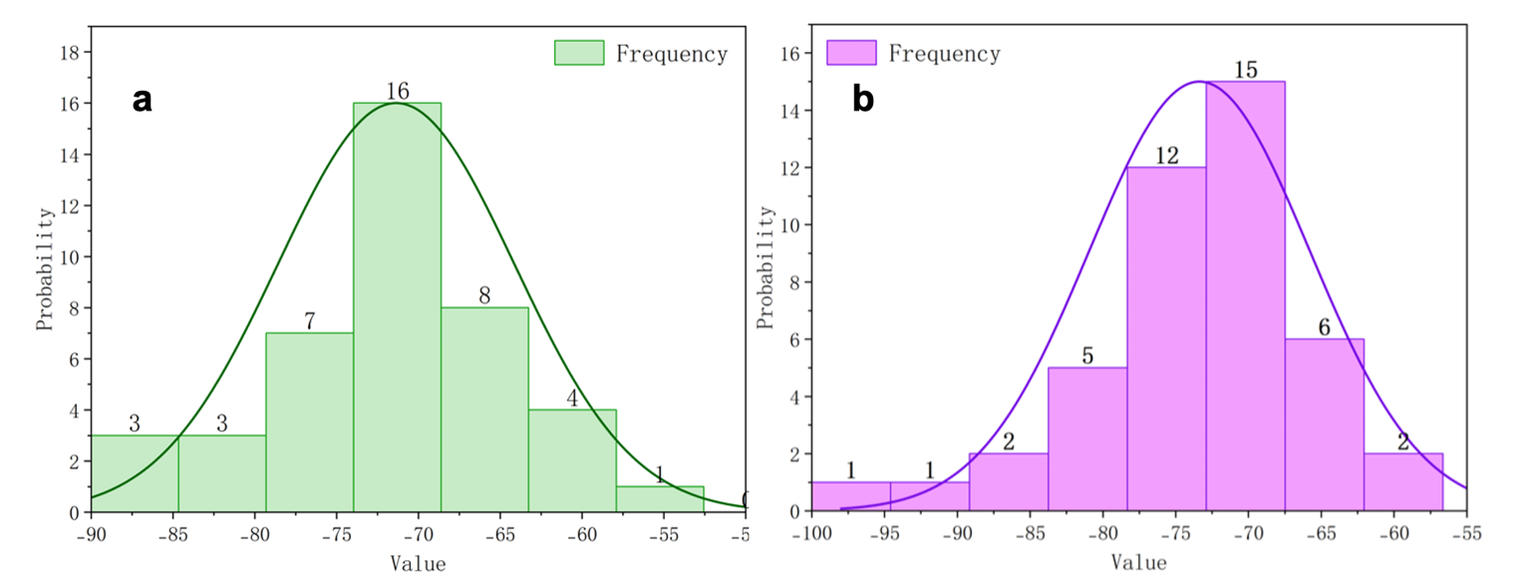
Figure 3-1. Histogram with Normal Distribution Curve of (a) PS-X and (b) PS-Y

Ⅳ Comparability Between Samples
In this section, we begin by generating boxplots to visually assess potential differences between the two sample groups. Statistical significance testing is then applied to validate these observations. A two-tailed test is typically employed to detect bidirectional differences. Additionally, the choice of specific statistical tests should align with the distributional characteristics of the data.

4.1 Unmodified Particles PS-X and PS-Y
The violin plot displays the distributions of PS-X and PS-Y. Both groups have similar medians, around -70. Their ranges are also quite alike, with PS-X spanning from -90 to -50 and PS-Y from -100 to -60. The interquartile ranges (IQRs) for both groups are similar in width. These similarities suggest that there may be no significant differences between the two groups.
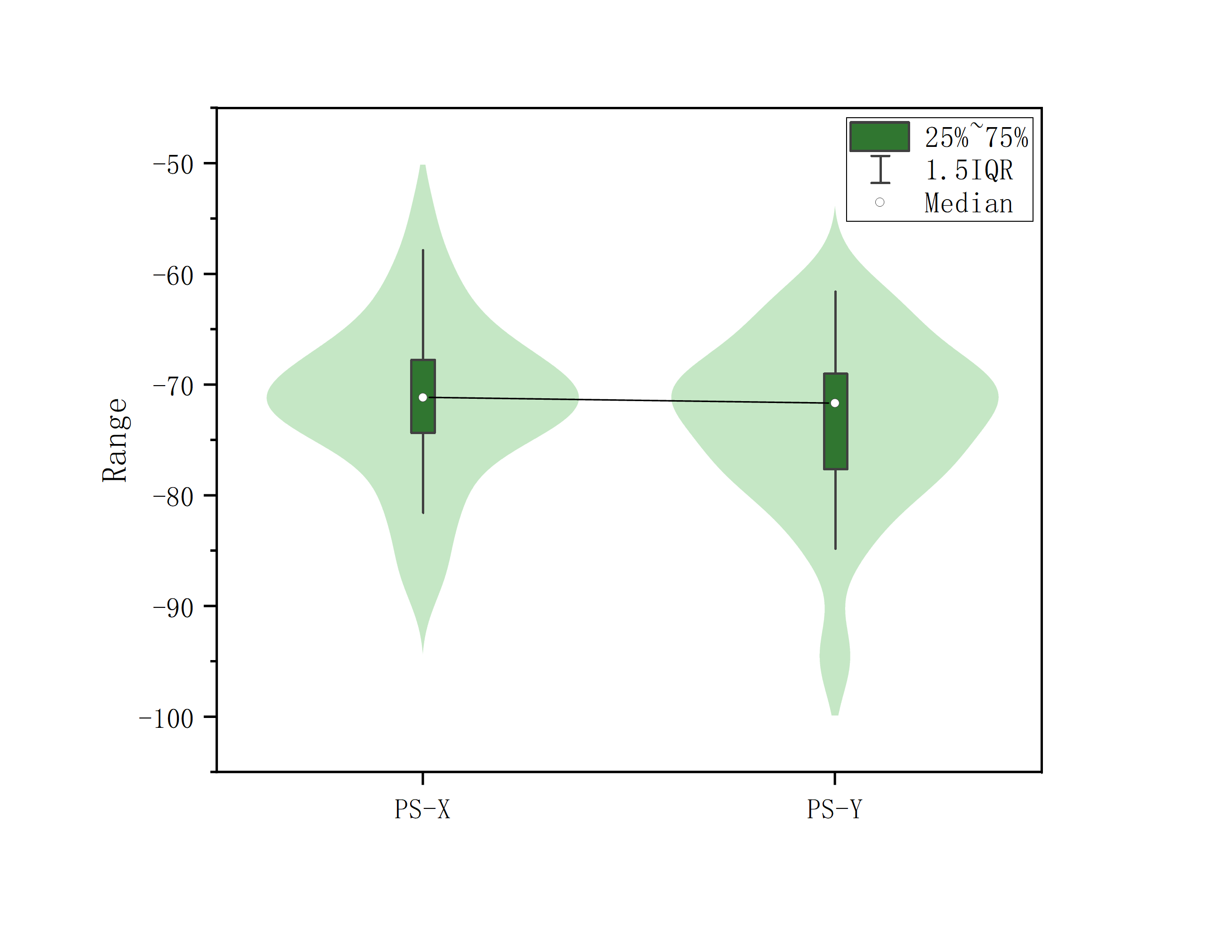
Figure 4-1. Violin diagram of PS-X and PS-Y.

As the sample sizes exceeded 30 (n > 30), the t-test is employed due to the necessity to assess the significance of mean differences between two numerical samples and the unavailability of z-test given that both population standard deviation and mean parameters remain unknown.

For the t-test, assume that:

$$α= 0.05, 5\% level$$
$$t_{critical}=t_{\left(1-\frac{α}{2},v\right)}$$
$$z = ±1.96 (2-tailed)$$
$$Null hypothesis H_{0}:\overline{X_{1}}=\overline{X_{2}}$$
$$Alternative hypothesis H_{1}:\overline{X_{1}}≠\overline{X_{2}}$$

And the quantities in the equation are defined below：

 | $$\overline{X_{1}},$$ | $$mean of unmodified particles-X$$
 | $$\overline{X_{2}},$$ | $$mean of unmodified particles-Y$$
 | S, | SD of C unmodified X and Y particles
 | N, | Sample size for unmodified sample set X and Y

Then, 2 tailed test will be conducted as follows.
T statistic value t can be calculated as:

$$t=\frac{{\overline{X}}_{1}-{\overline{X}}_{2}}{\sqrt{\left(\frac{{s_{1}}^{2}}{n_{1}}\right)+\left(\frac{{s_{2}}^{2}}{n_{2}}\right)}}=1.26$$

Degrees of freedom for equal variance v can be calculated as:

𝑣 = 𝑛−2 = (42+44) −2 = 84

According to the t critical value table below (Table 4-1), it can be obtained that:

$t_{critical}=t_{\left(0.975,84\right)}=1.98$9

Table 4-1. Critical values of Student's t distribution with ν degrees of freedom
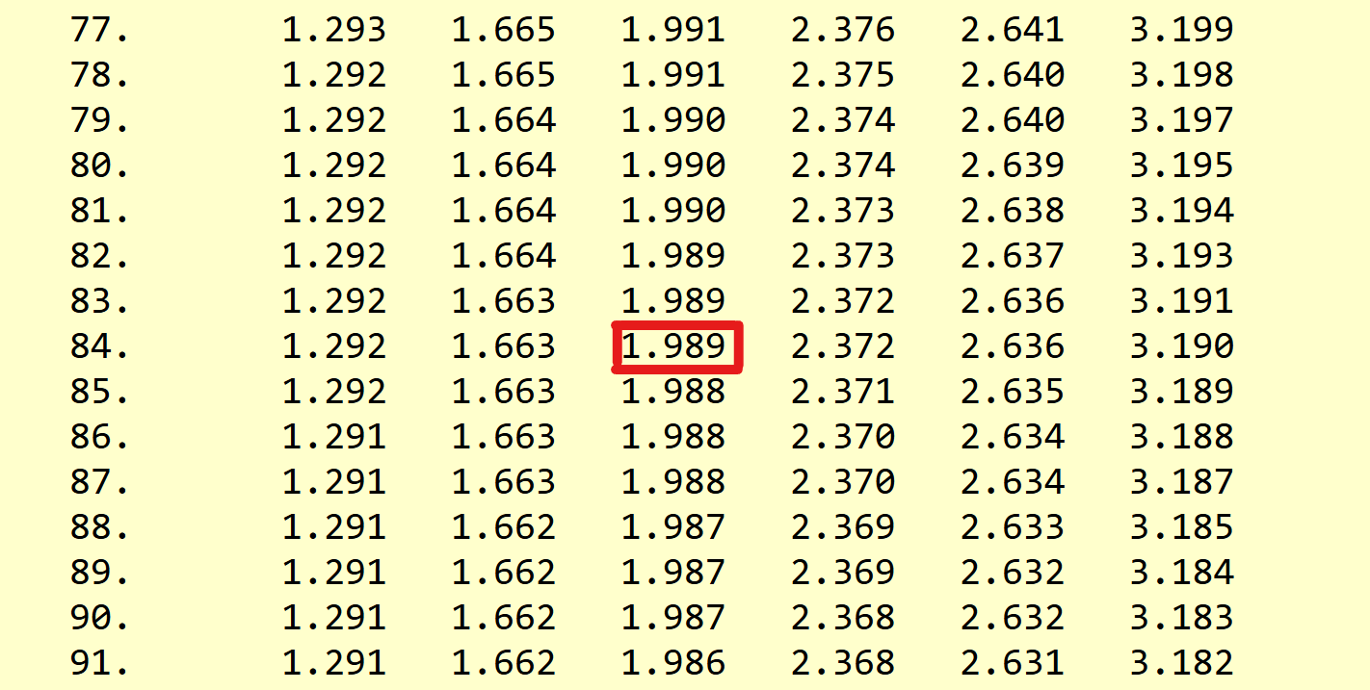

By calculated:

$$t=1.26<t_{critical}=t_{\left(0.975,84\right)}=1.989 accept H_{0}$$

Since t＜t_{critical} , null hypothesis(H₀) holds true. Therefore, there is no significant difference between the unmodified particles X and Y.

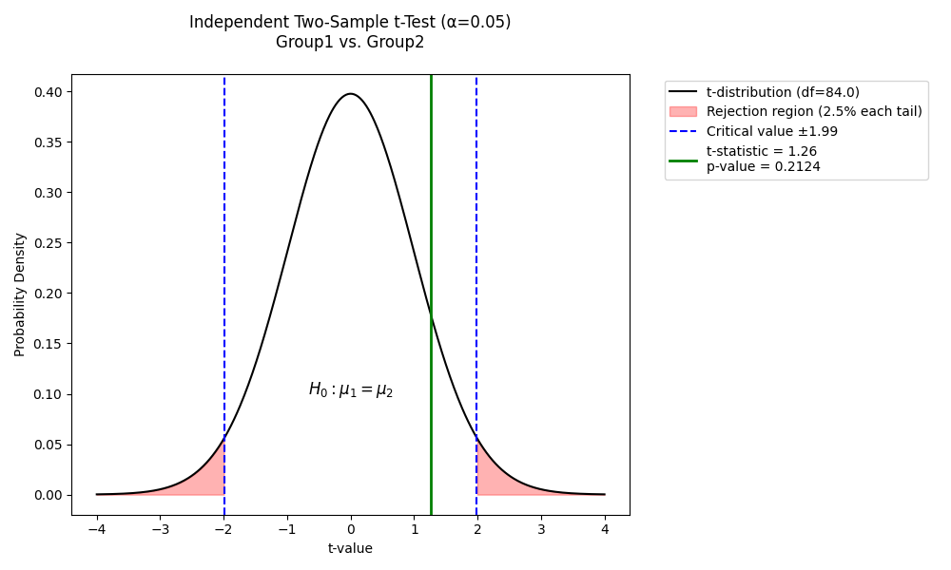
Figure 4-2. Independent Two-Sample t-Test(a=0.05) Group1 vs Group2

4.2 C and N terminal-modified particles
The violin plot shows that PA-C and PA-N have different data distributions. PA-C has a median of around -35 and a data range from approximately -50 to -25. PA-N has a median of around -30 and a data range from approximately -40 to -20. These differences suggest variations in the central tendency and spread between the two groups.
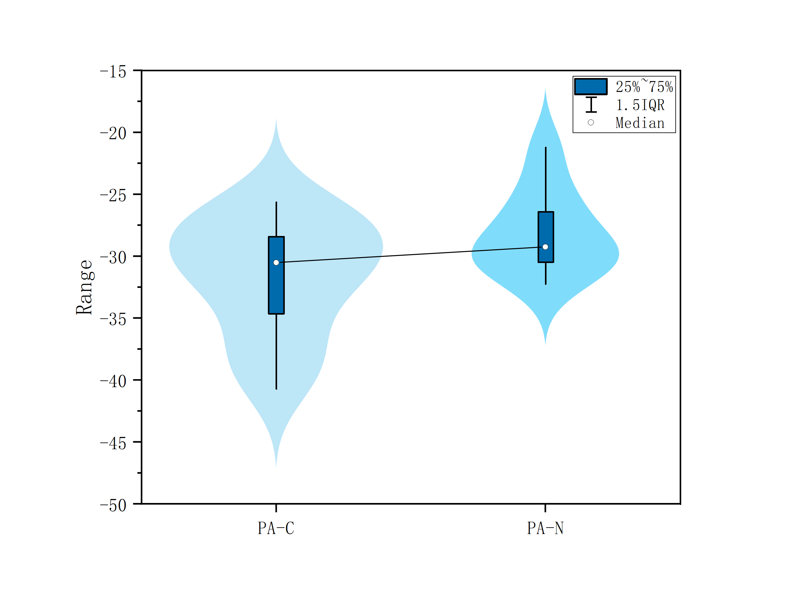
Figure 4-3 Violin diagram of C and N terminal-modified particles

The small sample sizes of C-terminal-modified particles (n=13) and N-terminal-modified particles (n=9) (both n < 30) preclude verification of normal distribution, thereby violating the prerequisites for t-tests and z-tests and rendering significance testing unfeasible.

4.3 Unmodified particles and modified particles
Based on the discussions in 4.1, it is concluded that two individual unmodified sample sets exhibit no significant differences. Consequently, they are merged into a single unmodified sample set with a total size of 86. The violin plot (Figure 4-4) clearly demonstrates that marked differences in medians and ranges suggest a statistically significant distinction between the two groups.

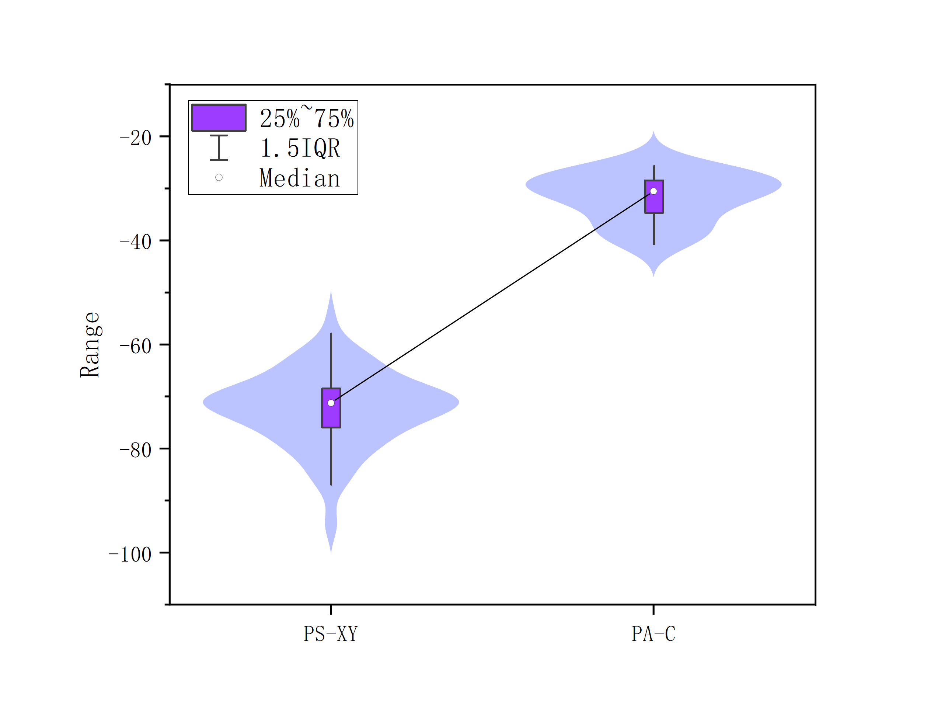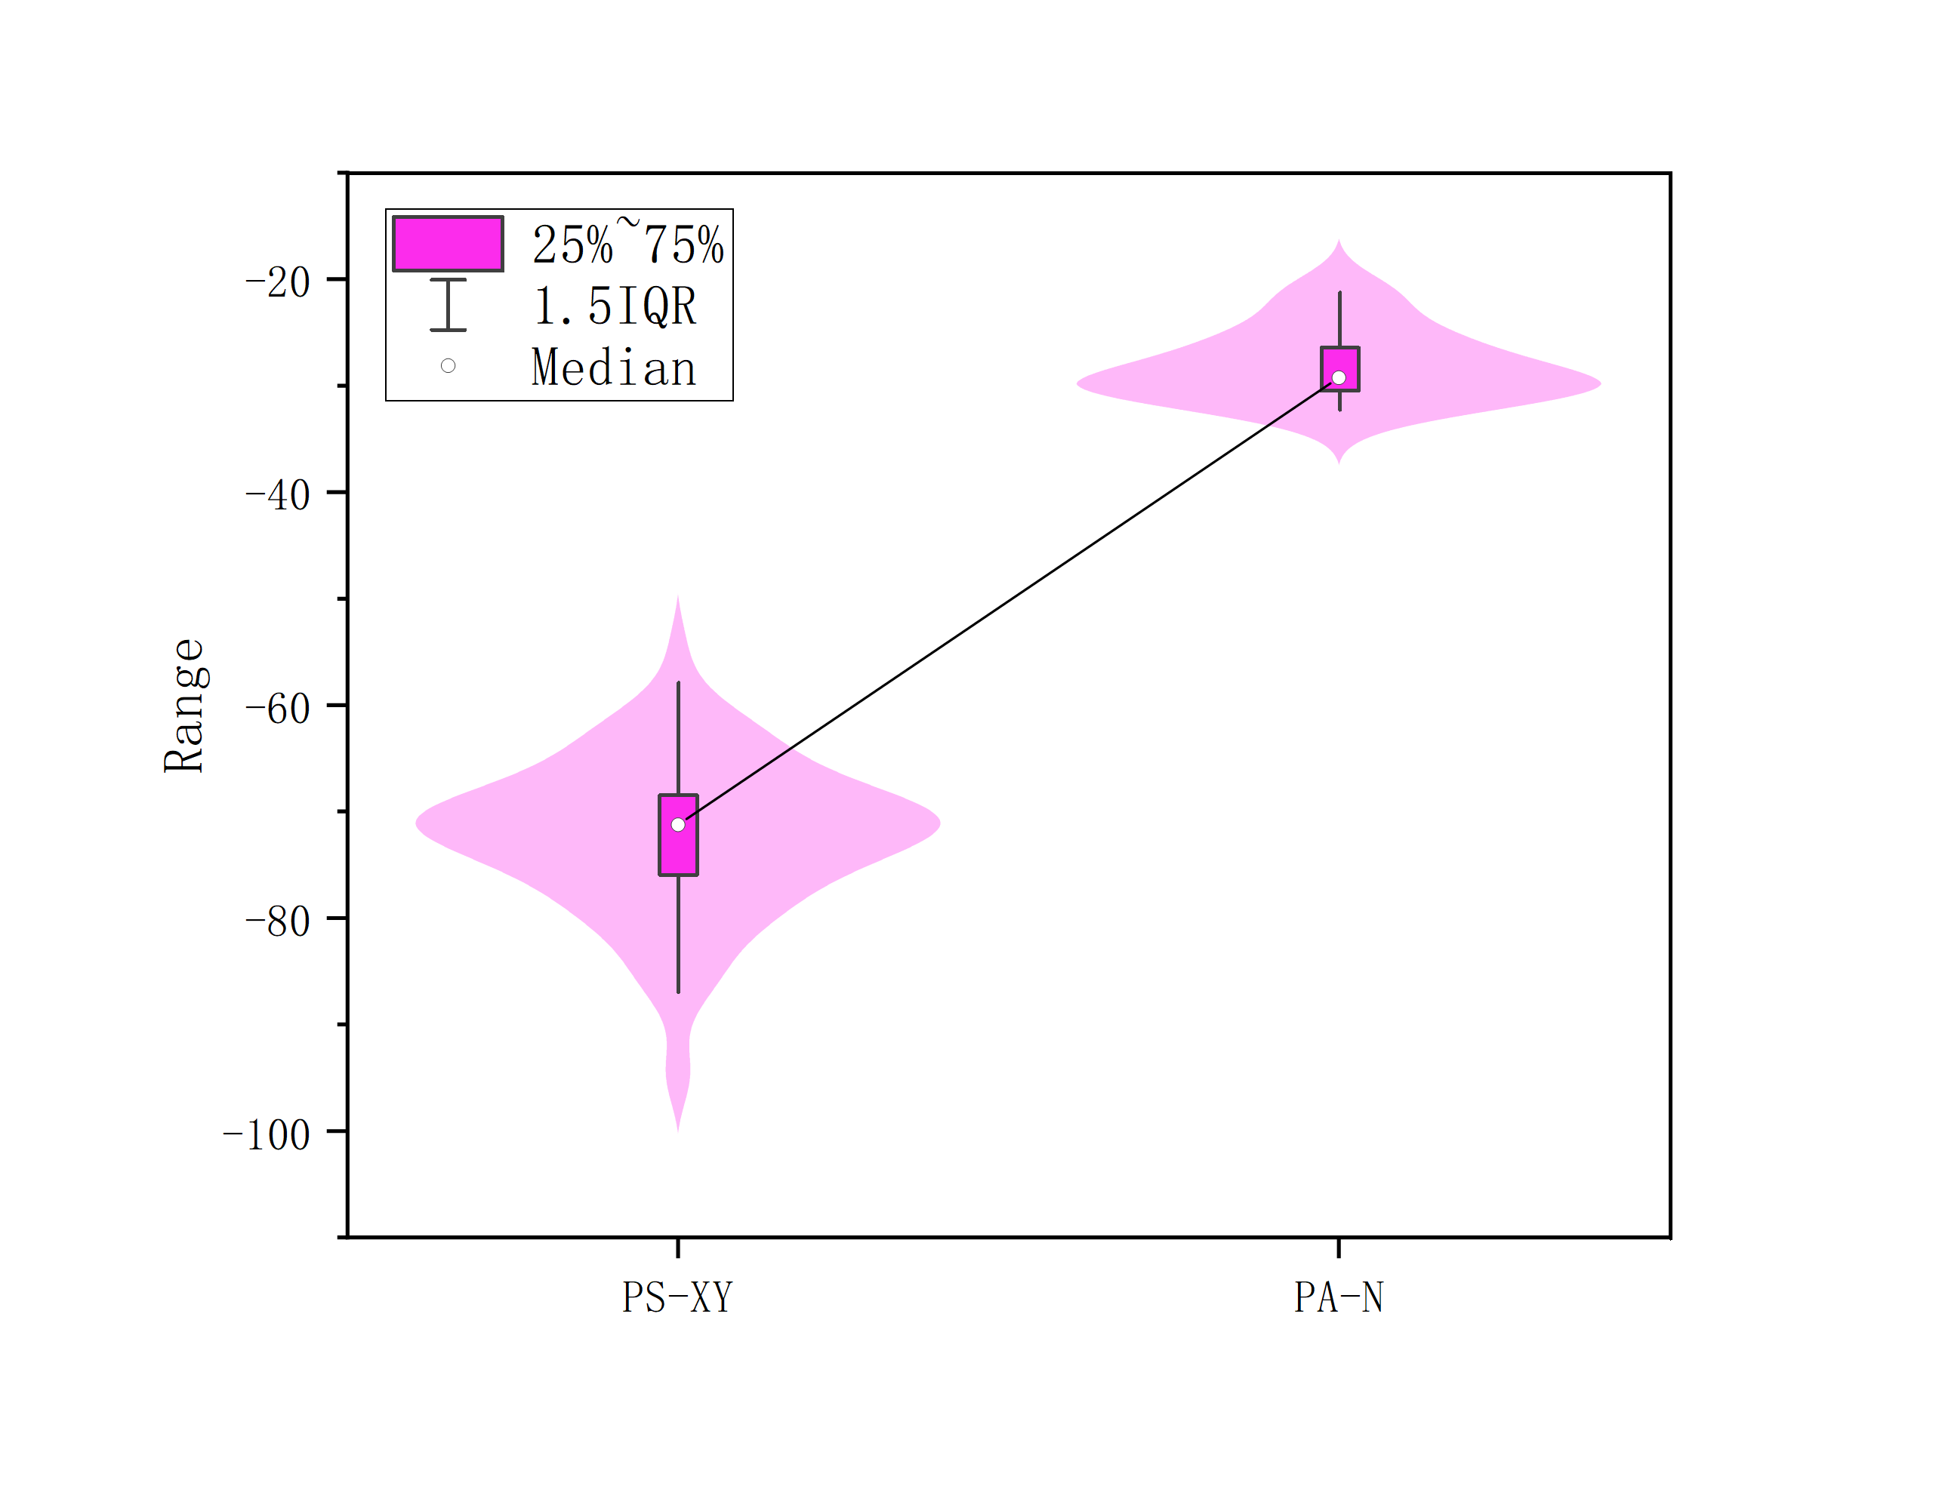
Figure 4-4. Violin diagram of PA-C and PA-N to PS-XY

With n > 30, the Central Limit Theorem applies, ensuring the sample mean equals the population mean (μ) and the sampling distribution is normal. This allows conducting a Z-test to compare unmodified particles with both C and N terminal-modified particles. For the Z-test, the quantities in the equation are defined as follows:

 | $$\overline{X},$$ | Means of C and N terminal-modified particles
 | $$μ,$$ | Mean of unmodified particles (population)
 | $$S,$$ | SD of C and N terminal-modified particles
 | $$n,$$ | Sample size for C and N terminal-modified sample set

Suppose null hypothesis(H0) holds true. 2 tailed Z-test will be conducted below:

$$H_{0}:\overline{X}=μ$$
$$H_{1}:\overline{X}≠μ$$
$$z=\frac{\overline{X}-μ}{S/\sqrt{n}}$$

Assume the significance level α = 0.05,5% level, z = ±1.96, result will be:

For C terminal-modified particles $\left|z\right|=\left|29.92\right|>\left|1.96\right|$ rejected H₀
For N terminal-modified particles$\left|z\right|=\left|38.15\right|>\left|1.96\right|$ rejected H₀

Based on the Z-test outcomes, the null hypothesis (H₀) for both C terminal-modified and N terminal-modified particles is rejected. This indicates a statistically significant difference between these modified particles and the unmodified particles.

Ⅴ Reflection
In this experiment, data should undergo validity checks immediately after acquisition to eliminate erroneous entries. Subsequent analysis requires integrating intuitive visualizations with theoretical frameworks. During data comparisons, rigid methodologies should be avoided in favour of critical reflection on the underlying objectives – consistently questioning the purpose of each analytical step. Maintaining focus on the experimental goals remains essential, with a clear definition of research objectives being imperative. Notably, discoveries beyond the original scope may emerge during the process, as exemplified by the findings in section 4.2.

While task delegation within teams proves necessary (e.g., assigning visualization tasks to some members and computational work to others), synchronizing conceptual understanding across all participants is critical to prevent fragmented or illogical outputs. A recommended practice involves conducting logic-alignment meetings prior to the final report compilation to streamline coherence and eliminate redundant efforts. Challenges such as repeated graph revisions due to overlooked specifications arose from inadequate preliminary planning regarding task requirements.

